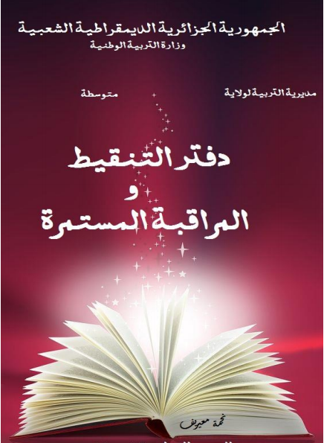

**دفتر التقويم للفصل الثاني 2024|2025 للقسم: .................**

|  |  |  |  |  |  |  |  |  |  |  |  |
| --- | --- | --- | --- | --- | --- | --- | --- | --- | --- | --- | --- |
| **الاستاذة: بوروينة نصيرة**  **المادة: الرياضيات** | | **المراقبة المستمرة** | | | | | | | | | |
| **المواظبة و الانضباط** | | | **المردود داخل القسم** | | | **المردود خارج القسم** | | | **المجموع** | **الفرض** | **الاختبار** |
| **الاسم و اللقب** | | **السلوك 2 ن** | **احضار ادوات التغلم 2ن** | **تنظيم الكراس 1ن** | **المشاركة 2ن** | **الفعالية 3ن** | **الانجازعلي السبورة و الكراس 2 ن** | **انجاز المهمات المسندة 3ن** | **العمل ضمن فريق 2ن** | **المبادرة و المساهمة 1ن** |
| **1** |  |  |  |  |  |  |  |  |  |  |  |  |  |
| **2** |  |  |  |  |  |  |  |  |  |  |  |  |  |
| **3** |  |  |  |  |  |  |  |  |  |  |  |  |  |
| **4** |  |  |  |  |  |  |  |  |  |  |  |  |  |
| **5** |  |  |  |  |  |  |  |  |  |  |  |  |  |
| **6** |  |  |  |  |  |  |  |  |  |  |  |  |  |
| **7** |  |  |  |  |  |  |  |  |  |  |  |  |  |
| **8** |  |  |  |  |  |  |  |  |  |  |  |  |  |
| **9** |  |  |  |  |  |  |  |  |  |  |  |  |  |
| **10** |  |  |  |  |  |  |  |  |  |  |  |  |  |
| **11** |  |  |  |  |  |  |  |  |  |  |  |  |  |
| **12** |  |  |  |  |  |  |  |  |  |  |  |  |  |
| **13** |  |  |  |  |  |  |  |  |  |  |  |  |  |
| **14** |  |  |  |  |  |  |  |  |  |  |  |  |  |
| **15** |  |  |  |  |  |  |  |  |  |  |  |  |  |
| **16** |  |  |  |  |  |  |  |  |  |  |  |  |  |
| **17** |  |  |  |  |  |  |  |  |  |  |  |  |  |
| **18** |  |  |  |  |  |  |  |  |  |  |  |  |  |
| **19** |  |  |  |  |  |  |  |  |  |  |  |  |  |
| **20** |  |  |  |  |  |  |  |  |  |  |  |  |  |
| **21** |  |  |  |  |  |  |  |  |  |  |  |  |  |
| **22** |  |  |  |  |  |  |  |  |  |  |  |  |  |
| **23** |  |  |  |  |  |  |  |  |  |  |  |  |  |
| **24** |  |  |  |  |  |  |  |  |  |  |  |  |  |
| **25** |  |  |  |  |  |  |  |  |  |  |  |  |  |
| **26** |  |  |  |  |  |  |  |  |  |  |  |  |  |
| **27** |  |  |  |  |  |  |  |  |  |  |  |  |  |
| **28** |  |  |  |  |  |  |  |  |  |  |  |  |  |
| **29** |  |  |  |  |  |  |  |  |  |  |  |  |  |
| **30** |  |  |  |  |  |  |  |  |  |  |  |  |  |
| **31** |  |  |  |  |  |  |  |  |  |  |  |  |  |
| **32** |  |  |  |  |  |  |  |  |  |  |  |  |  |
| **33** |  |  |  |  |  |  |  |  |  |  |  |  |  |
| **34** |  |  |  |  |  |  |  |  |  |  |  |  |  |
| **35** |  |  |  |  |  |  |  |  |  |  |  |  |  |
| **36** |  |  |  |  |  |  |  |  |  |  |  |  |  |
| **37** |  |  |  |  |  |  |  |  |  |  |  |  |  |
| **38** |  |  |  |  |  |  |  |  |  |  |  |  |  |
| **39** |  |  |  |  |  |  |  |  |  |  |  |  |  |
| **40** |  |  |  |  |  |  |  |  |  |  |  |  |  |
| **41** |  |  |  |  |  |  |  |  |  |  |  |  |  |
| **42** |  |  |  |  |  |  |  |  |  |  |  |  |  |
| **43** |  |  |  |  |  |  |  |  |  |  |  |  |  |
| **44** |  |  |  |  |  |  |  |  |  |  |  |  |  |
| **45** |  |  |  |  |  |  |  |  |  |  |  |  |  |
| **46** |  |  |  |  |  |  |  |  |  |  |  |  |  |
| **47** |  |  |  |  |  |  |  |  |  |  |  |  |  |
| **48** |  |  |  |  |  |  |  |  |  |  |  |  |  |